“Universities for EU Projects”
Project financed as mobility project for traineeship for higher education students - KA1 Erasmus+

CALL FOR HOST ORGANISATIONS
annex 1
to be filled in and sent to info@eu-gen.org

Organization profile

PIC (if applicable)
Full legal name (National Language)
Full legal name (Latin characters)
Acronym
Department (if applicable)
Address
Country
Region
Post Code
City
Website
Email
Telephone 1
Telephone 2

Type of organisation
Is your organisation a public body?
Is your organisation a non-profit?
Total number of staff
Number of trainees hosted in 2015/2016

Please tick the cell matching the income of the organization in the last year
Between 0 and 100.000 EUR
Between 100.001 and 500.000 EUR
More than 500.001 EUR

Legal Representative

Title
Gender
First Name
Family Name
Department
Position
Email
Telephone

Contact Person

Title
Gender
First Name
Family Name
Department
Position
Email
Telephone

Background and experience

- Please provide a brief description of your organisation (e.g. mission, areas of specific expertise, specific social context, target group, regular activities, etc.). (max 1000 characters with spaces)

- What are the activities and experience of your organisation, which are relevant to EU funded projects? (max 1000 characters with spaces)

- Have you applied for/received a grant from any European Union programme in the 3 years preceding this application?
If so, please indicate:

Title of the project approved | EU funding Programme | Year | Applicant organisation

- Does your organization plan to apply for any EU funded projects in the next year? (If so, please specify under which Programme, if you already know, or in which field of activity)

Candidates’ profile

- What is the trainees’ ideal personality, qualifications and skills?

- Which working language is required?

- Please give a rough description of the main daily tasks

- How many trainees are you willing to host at the same time?

- What is your favourite length of the mobility period?

- What kind of logistical support are you able to provide? (Office desk, computer, internet connection, printer, telephone, etc.)

- Do you provide any economic support?

- Do you provide any linguistic support?

- Where would the trainee(s) work from?

- Is there any possibility for the trainees to be hired after a successful traineeship experience?

- Would you be interested in being contacted for future traineeship projects?

MAIN FIELDS OF ACTIVITY

1. Agriculture, Fisheries and Foods
2. Economy, Finance and Tax
3. Education, Training, Culture and Youth
4. Employment and Social Affairs
5. Energy and Natural Resources
6. Enterprise and Industry
7. Environment, Consumers and Health
8. External Relations and Foreign Affairs
9. Information, Communication and Media
10. Justice, Fundamental Rights and Home Affairs
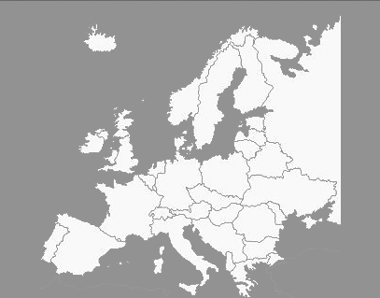 11. Regions and Local Development
12. Research, Innovation and Technology
13. Transport, Tourism and Travel

